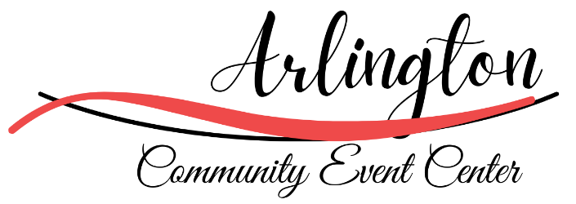
853 Main Street
Arlington, Iowa 50606
563-633-5140
Event Rental Agreement

ENTER INFORMATION:
Name: ______________________________________________________________________________
Company or Organization: ______________________________________________________________
Address: ____________________________________________________________________________
City/State/Zip: _______________________________________________________________________
Phone #: ___________________________________ Cell #: __________________________________
Email: ______________________________________________________________________________
EVENT INFORMATION:
Event Date: _________________ Event Start Time: ____________ Event End Time:_______________
Type of Event: __________________________________ Estimated # of Guests: __________________
Space Needing to Rent: Whole Center Meeting Room Meeting Room with Kitchen

Whole Center Rental - This deposit must be paid as a separate check from any rental or service fees.
$200 Security/Damage Deposit
$500 Center-Entire Day

$250 Center Half Day (6 hours or fewer, this includes setup & cleanup)

Small Meeting Room (Cleaning Included)
$150 for Room
$75 Kitchen
$10 per Hour for Gym access #________Hours
Other Options
$100 a night per bartender Expected number of bartenders _________
$5/per tablecloth Expected number of tablecloths _________

Rules and Regulations
RESERVATION & CANCELLATION POLICY
To reserve the Arlington Community Event Center for a specific date and time, the full rental fee must be paid in advance, and a signed Rental Agreement must be submitted. The rental fee applies to the specific day and area being reserved. The facility is not considered reserved until both payment and the signed agreement are received. Without these, the requested date may be booked by another party.
Cancellations made at least six (6) months in advance, with written notice, will receive a full refund.
ALCOHOL RESTRICTIONS
All charges related to bar sales are the responsibility of the individual or group hosting the event. A minimum of two (2) bartenders is required for all events. The Arlington Community Event Center will determine whether additional bartenders are necessary based on event size and needs.
No outside alcohol or consumption of alcohol outside the terms of the Arlington City Liquor License is permitted inside the facility or on the grounds. The Arlington Community Event Center reserves the right to refuse service to any minor, anyone unable to provide proof of age, or any visibly intoxicated person, in accordance with Iowa State law.
The Arlington Community Event Center may discontinue beverage service at its own discretion if Iowa alcohol laws are not followed. The host is responsible for helping to prevent underage drinking. Bar pricing and bar fees are subject to change and are not guaranteed due to price fluctuations
EVENT TIME FRAME & KEY PROCEDURES
All events must end no later than midnight (12:00 a.m.).
All cleanup must be completed, and all guests must be out of the building by 12:00 a.m.
Key Pick-Up & Return:
- The Arlington Community Event Center will call the renter approximately one (1) week before the event to schedule the key pick-up time.
- At the end of the event, all doors must be locked, and the keys must be placed in the tan box located on the wall in the entryway.
- Failure to lock the facility or return the keys properly may result in additional charges and/or loss of deposit.

DECORATION RESTRICTIONS
- No burning candles are allowed within the center. (Battery-operated candles are recommended.)
- Decorations must not cause damage to walls, ceilings, floors, tables, or other property.
- Use of nails, screws, staples, or any damaging fasteners is prohibited.
- Any damage caused by decorations, adhesives, or other materials will be charged to the renter.

SECURITY / DAMAGE DEPOSIT
A $200 security/damage deposit is required at the time the Rental Agreement is submitted. This deposit must be provided as a separate check from the rental fee.
- The deposit check will be held and not deposited, unless damages, excessive cleaning needs, or contract violations occur.
- Following the event, the facility will be inspected.
- If no issues are found, the deposit check will be shredded within 48–72 hours of the event’s conclusion.
- If damages or violations are identified, the check may be deposited to cover costs. The renter will be notified of any issues, and any expenses exceeding $200 will be billed directly to the renter.

LIABILITY & SMOKING POLICY
The Arlington Community Event Center is not responsible for any accidents, injuries, or lost items occurring at or on the Event Center’s grounds.
The Arlington Community Event Center is a smoke-free facility. Smoking is prohibited inside the building. Smoking is only allowed outside in specified smoking areas, and cigarettes must be disposed of in specified receptacles.

TABLECLOTH RENTALS
The Arlington Community Event Center offers white and black tablecloths for both round and long tables. Rental cost is $5 per tablecloth. The Event Center will wash and clean all rented tablecloths after the event.

OCCUPANCY LIMITS
The Arlington Community Event Center can accommodate up to 390 guests. The renter agrees not to exceed this occupancy limit.

ACKNOWLEDGMENT & SIGNATURES
By signing below, the renter acknowledges that they have read, understand, and agree to all terms and conditions set forth in this Arlington Community Event Center Rental Agreement. The renter accepts responsibility for themselves, their guests, and any vendors present during the event.
Deposit: $200.00 Check #__________________ Cash: $__________________
Payment made by: Check $_______________ Check#__________________ Cash: $__________________
Signature of Renter: ________________________________________________ Date: _________________________
Printed Name: ___________________________________________________________________________________________
Please mail agreement to: 853 Main Street, Arlington, IA 50606

